**Research paper on Bluetooth based Home Automation using Arduino**

**Mr. Vaibhav Malav1, Mr. Raushan Kumar Bhagat2, Mr. Rahul Saini 3,**

**Mr. Udit Mamodiya4**

Poornima Institute of Engineering and Technology Jaipur, India

**Electrical Engineering**

**Email: - [vaibhavmalav692@gmail.com](mailto:vaibhavmalav692@gmail.com) ,** [**raushanbhagat8298@gmail.com**](mailto:raushanbhagat8298@gmail.com)**,** [**rahul35saini1234@gmail.com**](mailto:rahul35saini1234@gmail.com)**,** [**udit.mamodiya@poornima.org**](mailto:udit.mamodiya@poornima.org)

**Abstract: -** The world is moving fastly towards automation. People have less time to handle any work so automation is simple way to handle any device or machine will work to our desire. This paper aim is to develop and design a Home automation using Arduino with Bluetooth module. Home automation system gives a simple and reliable technology with Android application. Home appliances like fan, Bulb, AC, automatic door lock are controlled by Home automation system using Arduino Uno with Bluetooth module. The paper mainly focuses on the monitor and control of smart home by Andorid phone and provide a security based smart home, when the people does not present at home. This paper motive is controlled home appliances in smart home with user friendly, design at low cost, simple installation.

**Keyword: -** Arduino, Home automation, Bluetooth, Smart phone, Security

**I. Introduction**

Now days everyone has smart phone and wants to control everything from smart phone. Everyone knows how to control mobile phone so it easy to use and understand. Lights, fan , switches , refrigerator are controlled through Bluetooth based remote using arduino. The designing of home automation are going to become simpler and more popular because most of people uses smart phone now days. In this device we are using Arduino which is most commonly used device for automation. Arduino is a hardware which is used to connect computer and the project model so that we can control it by using Arduino code accordingly. Ardiuno is a microcontroller it is just like human brain it processes information and then it perform some Logical and mathematical operation on that information. Arduino is connected with the Bluetooth module which receives the information from user. Arduino also connected relay, which receives information from Arduino and perform the operation as switch. Bluetooth technology is Wireless radio transmissions in a short distance providing a necessary technology to create intelligence and controllability. This generates personal area network in home environment, where all these appliances can be interconnected and monitored using a microcontroller with Arduino using smart phone. Home automation involves a degree of computerized or automatic control to certain electrical and electronic systems in a building.

**II. Methodology**

Home automation describes a system of networked, controllable device that work together to make your home more comfortable, customized, efficient and secure. In this device there are five main parts Arduino, Bluetooth module, Relay drivers, android application and step down transformer. Firstly we provide power to the step down transformer, it step down the input voltage and given to the arduino with VIN pin. The Bluetooth module is also connected with arduino to Rx and Tx pin that provides the information to the microcontroller. Microcontroller reads the information and send to the relay drivers which work as switch. In Arduino we upload the program as per requirement then it performs some mathematical and logical operation to control the relay drivers.

Those all parts are connected as shown in figure 2(a).

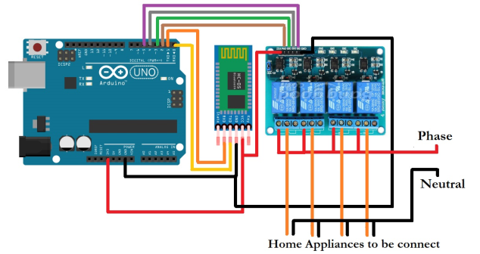

**Fig2(a)-circuit diagram of home automation.**

Android application are connected to the arduino Bluetooth (HC-05). In the figure 2(b) there are four switches which is connected to relay drivers and four relay are connected to the home appliances.

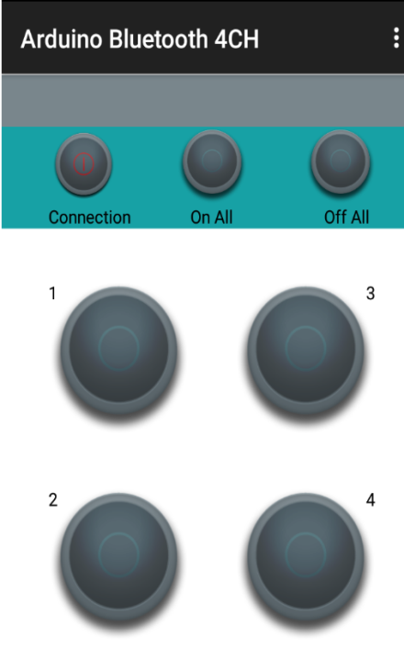

**Fig.2(b)-Mobile android application.**

**III. Architecture of the Device**

This venture centres around the robotization of machines with the assistance of an android application. In this day and age, enhancement is the primary thought process . Any framework created goes for streamlining the human endeavours to a negligible and our framework goes for doing likewise. The architecture of this device as shown in figure 3(a).

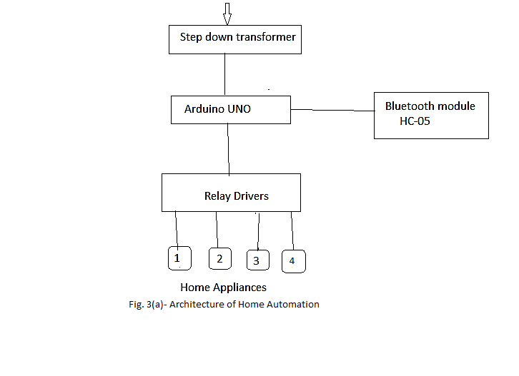

The user will communicate to Android application through the Arduino Uno via Bluetooth module. This model is very resilient and gaugeable, maximum efficiency, safety and securely added smart home appliances with least amount of human effort . The Bluetooth signal having most efficient energy to connect any signal without loss of information with least harmonics .Home automation system main part consists of Arduino with microcontroller. The people must have mobile application with proper connection. It should be used as multi appliances works as together. The Arduino board is configured for each home appliances using coding in microcontroller. By the help of Microcontroller, we can control the electromagnetic relay which works as a switch to receive a signal from the Arduino through Bluetooth module HC-05. When the signal transmit from transmitter as datasheet to relay then the relay works as switch and control many appliances of smart home(multitasking) .There are three main parts of this home automation which is given below.

1. Arduino Uno

2. Bluetooth HC-05

3. Relay Drivers

**IV. Description of Hardware**

**1. Arduino Uno:-**

Arduino Uno is a microcontroller chip dependent on the Atmega328(datasheet) with 14 computerized I/o pins, in which 6 pins can be utilized as yields, 6 pins are utilized as simple information sources .It has 16 MHz clay resonator ,a USB association, a power jack and a reset button. The microcontroller has 32kB of ISP flash memory, 2kB RAM and 1kB EEPROM. The board provides serial communication capability via UART, SPI and 12C.Because of well design in the form of arduino it is easy to understand. In Arduino we use high level of programming language like C language, C++ language ect. It is easy to understand and user friendly language. It has much advantage like multitasking, automation, time domain etc. Arduino Uno fig4 (a) is given below.

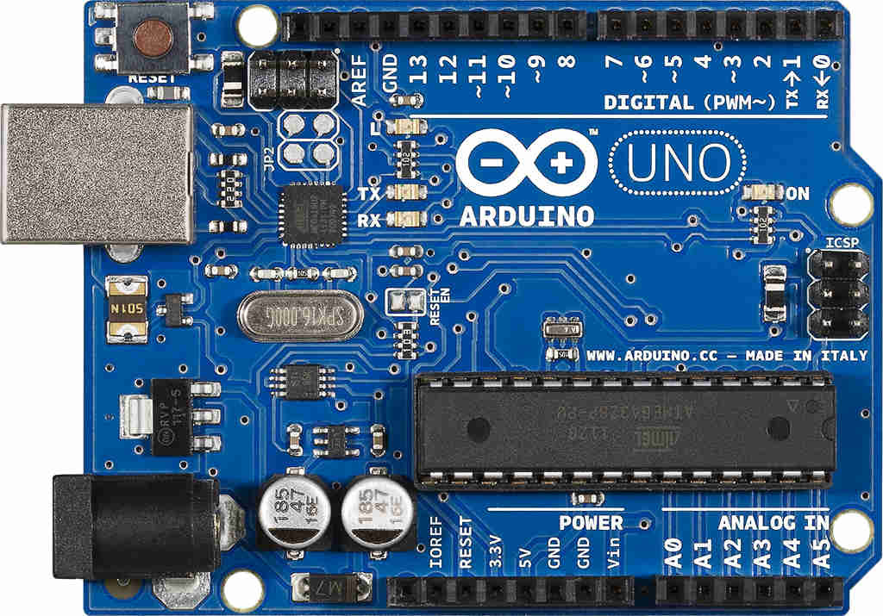

**Fig 4(a)-** Arduino Uno

**2. Bluetooth Module:-**

HC-05 Bluetooth module is used to connect the microcontroller with android application. Bluetooth receive the information from user and send to the microcontroller (Arduino Uno). It is simple to use Bluetooth Serial Port Protocol(SSP), designed as wireless serial connection setup.The Bluetooth of serial port module is Advanced Bluetooth v2.0+Enhanced data Rate at 3Mbps modulation with 2.4 GHz radio receiver with BB(base band).The Bluetooth of Rx and Tx pins are connected to the arduino pins of Tx and Rx respectively . HC-05 module is a simple to utilize Bluetooth SPP (Serial Port Protocol) module, intended for straightforward remote sequential association setup. It utilizes CSR Blue canter 04-External single chip Bluetooth framework with CMOS innovation and with AFH (Adaptive Frequency Hopping Feature). It has the impression as little as 12.7mmx27mm.The figure 4(b) of Bluetooth HC-05 module is given below.

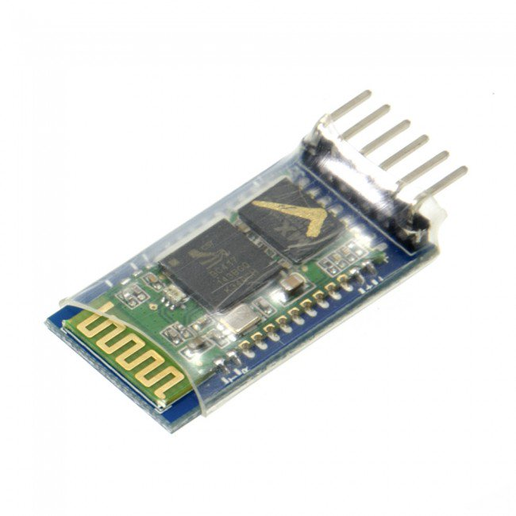

**Fig 4(b) Bluetooth HC-05.**

**3. Relay Drivers:-**

Relay is an electromagnetic switch which is used to defer two circuits electrically and connect magnetically. When arduino transmit the signal then relay driver receive signal and start its work. They are frequently used to interface an electronic circuit (working at low voltage) to an electrical circuit which works at extremely high voltage. For instance, a hand-off can make a 5V DC battery circuit to switch 230V AC mains circuit. In this way a little sensor circuit can drive, say, a fan or an electric knob. A transfer switch can be separated into two sections: information and yield. The info area has a loop which creates attractive field when a little voltage from an electronic circuit is connected to it. This voltage is known as the working voltage. Generally utilized transfers are accessible in various arrangement of working voltages like 6V, 9V, 12v, 24V and so on. In a basic hand-off there are three contactors: ordinarily shut (NC), regularly open (NO) and normal (COM). At no info express, the COM is associated with NC. At the point when the working voltage is connected the transfer curl gets charged and the COM changes contact to NO. Diverse transfer setups are accessible like SPDT and DPDT which have distinctive number of changeover contacts. By utilizing legitimate blend of contactors, the electrical circuit can be turned on and off. Relay circuit shown in fig4(c).

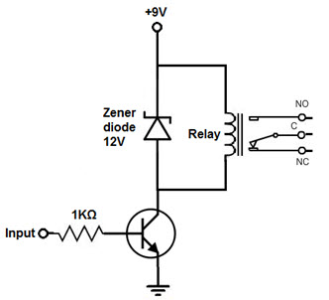

**Fig 4(c) Relay circuit diagram**

So as to drive the hand-off, we use transistor and just less power can be utilized to get the transfer driven. Since, transistor is an intensifier so the base lead gets adequate current to make increasingly current stream from Emitter of Transistor to Collector. In the event that the base once gets control that is adequate, at that point the transistor lead from Emitter to Collector and power the transfer. When the power is transmit to the relay works as a switch due to electromagnetic effect so that we can switch ON or OFF our home appliances.

The figure 4(d) of relay is given below.

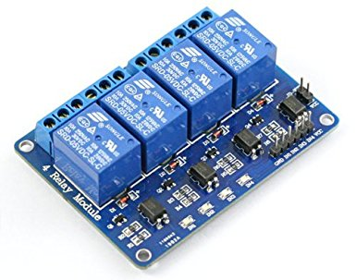 **Fig 4(d) Relay module**

**V. Advantage**

1. Everything is automated so it is easy to use.
2. It is control by mobile application so no extra training is required.
3. We can change controlling system as our requirement.
4. It works on arduino based system so we can easily understand how it works.
5. It saves our time.
6. Every home appliance can control by one android application.
7. Easy installation and user friendly.

**VI. Result**

According to the proposed plan the final outcome of this paper leads to the development of a home automation. Through this project, an automation system has been created so that we can easily control home appliances like as light, fan, tube light, AC, bulb, etc. One of the objectives of this project is also to get us a smart automation and low cost project. In this paper we have also provided information about arduino Uno, Bluetooth controller and relay module. And the information about their work is given. Along with the component of home automation, its advantage has also been discussed. The system is easy and secured for access from ant user or intruder. Final outcome of the project is given below in fig 5(a)(b)(c)(d).

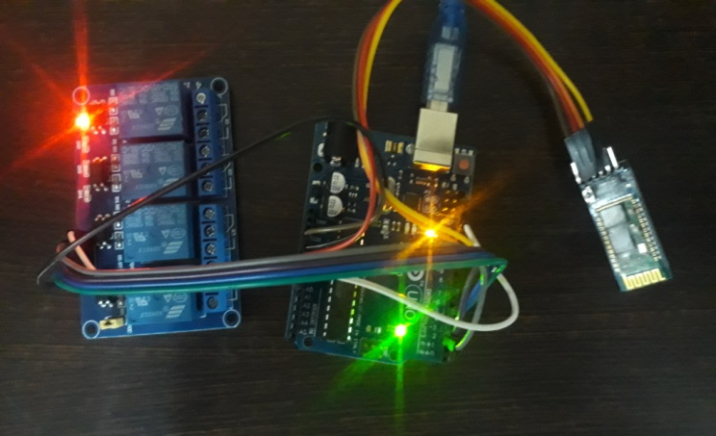

**Fig 5(a) Arduino with relay module**

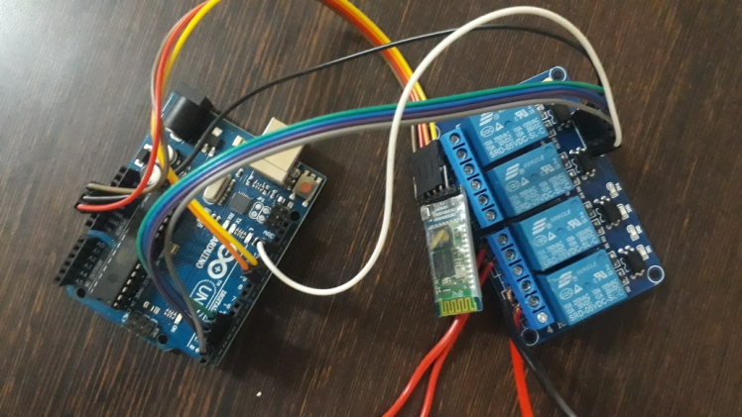

**Fig 5(b) Arduino with Bluetooth**

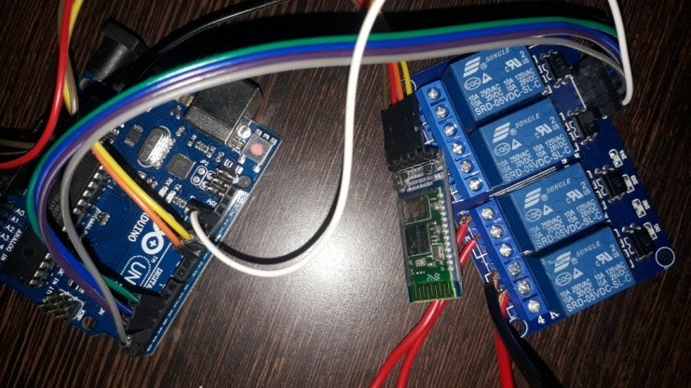

**Fig 5(c) Relay module with Bluetooth**

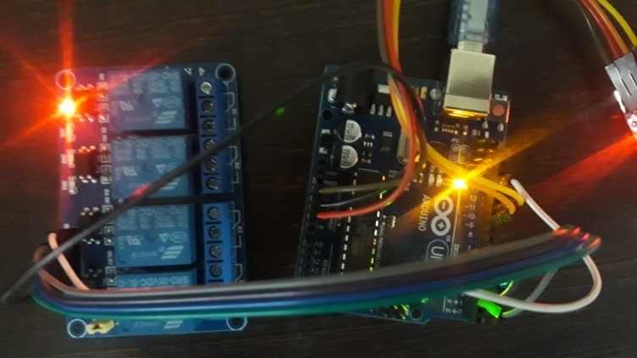

**Fig 5(d) Home Automation**

**VII. Conclusion**

It can be concluded from the above discussion that Home automation is a special kind of device which controls home appliances with using extra effort. And in this paper, we demonstrated how the home automation is made, discussed about methodology and what its application can be. And in the future, on the new technology can be included which reduces human effort, which is being researched, we also talked about it. And we've created a that type of device which is compact in size, low cost, more capacity, long life and  more distant signal receivers . The need of this research paper is to create a device which saves the electricity and improve human life style.

**VIII. References**

 [1]. N.David, A.Chima, A.Ugochukwu and E.Obinna,”Design of a home automation system using Arduino”, International journal of Scientific & Engineering Research, Vol. 6, pp. 795-801, june-2015.

[2]. Prof. M. B. Salunke, Darshan Sonar, Nilesh Dengle , SachinKangude, Dattatraya Gawade, “Home Automation Using Cloud Computing and Mobile Devices”, Vol. 3, Issue 2 (Feb. 2013), ||V2|| PP 35-37

[3]. A. ElShafee and K. A. Hamed, "Design and Implementation of a Wi-Fi Based Home Automation System, "World Academy of Science, Engineering and Technology, vol. 68, pp. 2177-2180, 2012.

[4]. Ahmed Elshafee, Karim Alaa Hamed, "Design and Implementation of a Wi-Fi based Home Automation System”, International Journal of Computer, Electrical Automation, Control and Information EngineeringVol: 6, No: 8, 2012, pp 1074 - 1080.

[5]. Zekeriyakeskin, Yunus Emrekocaturk, okan Bingol, Kublai Tasdelen, “Web-based smart home automation: PLC controlled implementation”, vol11, NO 3, 2014.

[6]. Silviu Folea, Daniela Bordencea, Casiana Hotea, Honoriu Valean “Smart Home Automation System Using Wi-Fi Low Power Devices”.

[7]. Mitali Patil, Ashwini Bedare, Varsha Pacharne "The Design and Implementation of Voice Controlled Wireless Intelligent Home Automation System Based on ZigBee." International Journal of Advanced Research in Computer Science and Software Engineering.

[8]. Mansour H. Assaf, Ronald Mootoo, Sunil R. Das, Emil M. Petriu, Voicu Groza, and Satyendra Biswas “Sensor Based Home Automation and Security System.” 978-14577-1722-7/12/$26.00 ©2012 IEEE.

[9]. A. R. Al-Ali, Member, IEEE, M. AL-Rousan”Java-Based Home AutomationSystem” IEEE Transactions on Consumer Electronics, Vol. 50, No. 2, May 2004.